# Blocks World For Teams using GOAL

Maaike Harbers, Wouter Pasman, Birna van Riemsdijk, ContextProjectGroup2014

June 2014

# Introduction

This document describes how to install Blocks World For Teams (BW4T) for use with GOAL. BW4T is a *client-server* system. The *server* is responsible for the administration, simulation and visualization of the virtual world: it keeps track of robots, rooms, blocks, connected GOAL agents, etc. The server uses Repast, software to simulate virtual environments, to do part of this administration. The *client* is GOAL, which runs a multi-agent system (MAS) and connects to the server. The agents in the GOAL client get percepts from the server, and send actions to the server. Client and server can run on a different computer. This document describes how to install the BW4T server, configure it, place the BW4T client in GOAL, configure the MAS file, and run the system.

We use the following names to refer to directories of BW4T:

* <GOAL> refers to the directory where you installed GOAL.
* <SERVER> refers to the directory where you have put the server.jar file.
* <CLIENT> refers to the directory where you have put the client.jar file.

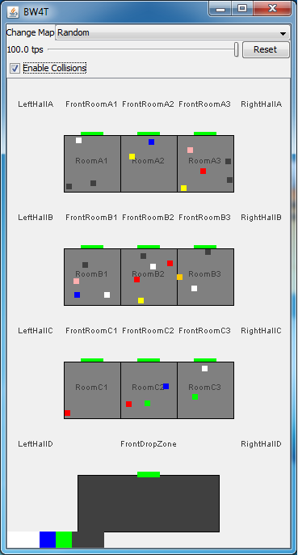

# System requirements

To use BW4T you need Java JDK 7 or higher. The BW4T3 environment has been tested on Windows 7, Windows 8 and OSX.

# Running the Server

Run the server before running the client, as otherwise the client cannot connect to the server. Start the server by opening the server.jar in <SERVER>. This should open the server window (Figure 1). Note that during this opening, two other maps are created:

* Maps: The folder in which all possible maps are put.
* Log: The folder in which all log files will be placed.

Figure 1. Server window showing the actual state overview window of the Environment

# Advanced run settings (Server)

The default settings for the server can be changed in the command line of your OS. To change the server ip and/or server port execute the following:

* java –jar bw4t-server.jar –servip *<server ip here>* (default: localhost) –serverport *<serverport here>* (default: 8000)

If you change the serverip and/or serverport, change the client settings correspondingly (see below).

The server will now start using the new values.

# Running the Client (Human controlled bot)

Before running the client, make sure you have already started the server. Start the client.jar in <CLIENT>. Figure 2 will show up and the bot is automatically added to the server. You can now control the bot by clicking (left or right) at different spots in the Client.

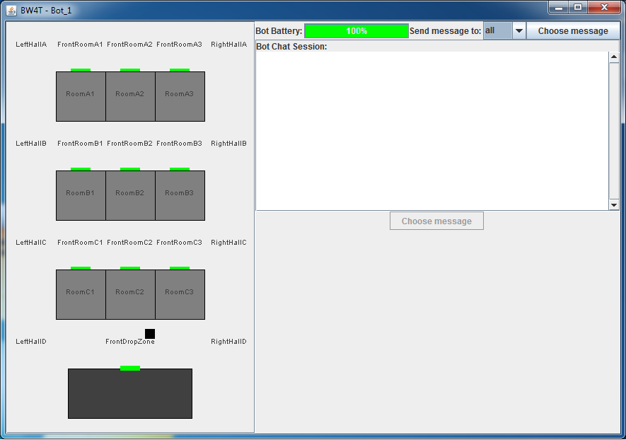

Figure 2. Client containing one human controlled bot.

# Running the Client (Agent controlled bot)

Before running the client, make sure you have already started the server. Start Eclipse IDE and load your GOAL files. Open the .mas2g file and press the run button. This time, no new window will appear. The agent will control your bot and all evaluations will be shown in the console. In the server window you will see your bot(s) move according to the rules applied in the .goal file(s).

## Advanced run settings (Client)

The default settings for the client can be changed in the bw4t.mas2g file (GOAL). The following settings can be changed.

* Serverip: the ip address that the server listens on (default: localhost).
* Serverport: the port that the server listens on (default:8000).
* Agentcount : the amount of agents (also specified in the launchpolicy section, see below), that the client should load. If the agentcount is higher than the amount of entities in the map then they won’t be loaded. (default: 0).
* Humancount: the amount of human players that should be loaded. If the humancount is higher than the amount of entities in the map then they won’t be loaded. (default: 0).
* Clientip : the ip address that the client listens on (default: localhost).
* Clientport : the port that the client listens on (default: 2000).
* Launchgui: whether to launch a separate GUI for each bot (controlled by an agent or human) can be set to true or false. This GUI shows the environment from the perspective of the bot. (default:false).
* Map. The map name to be loaded. If you specify a map, the server will reset to load the new map, which disconnects all entities.

The number of agents is specified at two places in the mas2g file. First, the agentcount and humancount specify the number of entities of the corresponding type that should be created in the environment. Second, the launchpolicy specifies which and how many agents should be connected to these entities. Make sure that the agentcount and humancount in the initialization parameters are in line with the launch policy section in the mas2g file. Furthermore, the number of agents should not exceed the maximum number of agents defined on the map (see section “Loading and creating new maps” below).

If you use BW4T from a batch runner, you may want to reset the server after each run. This is done by specifying a map in the mas file init parameters.

# Restarting, pausing and resuming the system

To be able to pause the system, don’t run the mas2g file as described above.

This time, open the mas2g file and click on the debug button (the small bug icon).

Eclipse will ask you whether you would like to go to the debug screen, click yes and watch your screen adjust.

Now you can see the running bots listed at the left side, and the current goals, beliefs and knowledge of the selected bot on the right side. Beneath the list the goal file belonging to the bot is shown and at the bottom of the screen, all debug actions are being run.

To pause the system, select the bot to be paused and click on the pause button. To resume, select the bot and click resume.

To restart the system, do the following

1. In eclipse, kill the MAS by clicking the red box (stop button) at the right of the console window.
2. In the server window, press **Reset, o**r choose a new map from the Change Map menu.
3. Run the MAS in Eclipse as described above.

# Loading and creating new maps

## Using the map editor

The Map Editor is a tool for editing maps for the BW4T server (Illustration ). Double click the jar file environment-store.jar to start the map editor.

|  |  |
| --- | --- |
|  |  |
|  | Illustration 4: The map size dialog |

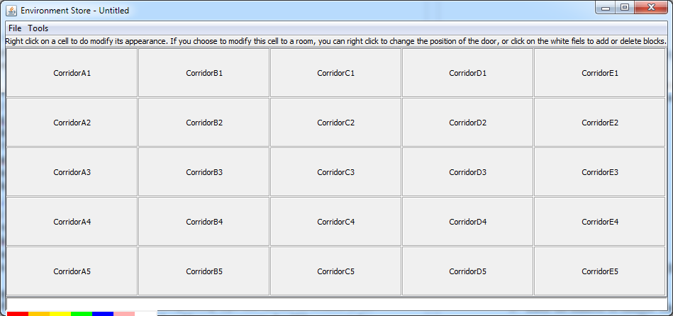After starting up, the map size dialog (Illustration 4) appears, which can be used as follows.

Here you can choose the amount of rows and columns you want the environment to consist of. Each cell in the “table” can be used to fulfill one piece of the map. This could either be a room, a corridor, a dropzone, a charging zone, start zone or a blockade. By pressing the colours at the bottom you can generate the sequence to be completed. This can also be done by pressing the according numbers on the keyboard.

In the Map editor GUI above you can add blocks to rooms. To add blocks to rooms, right click in the cell, adjust the type of the zone to Room. Now you can add blocks the way you did with the sequence. Right clicking the cell again lets you choose at which side of the room you want the door. When you're done, press save.

By pressing Tools in the menu bar, you are able to randomize zones, blocks and sequences. WARNING: Randomizing these will not always guarantee that the sequence can be completed.

By pressing File in the menu bar, you are able to watch a preview of your map, and you are able to save the map. Save the map in the <SERVER>/maps folder.

## Manual Editing

It is also possible to manually edit a map as it is a plain text XML file.

1. Copy an existing map file in the <SERVER>/maps folder to a new file.
2. Open the copied map with a text editor. You can then edit the colors in the rooms. Each <blocks>COL</blocks> line inside a <zones> of type ROOM adds another block to the room. The currently available colors are BLUE, ORANGE, RED, WHITE, GREEN, YELLOW AND PINK. A room has place for at most 10 blocks.
3. You can change the number of rooms by adding or removing <zones> of type ROOM and position the rooms correctly on the map by editing the <x> <y> <width> and <height> inside the room's <boundingbox>. Also you need to add a <door> properly positioned on the border of the room.
4. You can edit the goal sequence by adding <sequence> items to the map, with colors as mentioned above.
5. You can prevent multiple entities to enter corridor zones by putting true in the item <oneBotPerCorridorZone> in the map.
6. You can add entities to the environment by creating more <entities> items. Make sure they have a unique <name> and that their start position is in a different <zone> if you have <oneBotPerCorrridorZone> set to true[1].
7. You can let the server pick a random sequence of a given length by setting the <randomSequence> to a positive value. These random blocks are added to the existing sequence items and the random blocks are placed randomly on the map.
8. You can let the server pick random extra blocks to be placed in the rooms on the map by putting a positive number in the <randomBlocks> in the map. Note that this addition is on top of all blocks that are already placed in the map; so normally you leave the room zones empty when using this option.
9. You can set per-zone visibility of the zone namelabel in the server map renderer, using a <renderOptions> <labelVisible> false </labelVisible> </renderOptions> block to disable visibility.
10. Save the map in the <SERVER>/maps directory.
11. Edit the map initialization parameter for the server to your new map file. See the section on customizing the server settings. If you now start the server and your new map should be loaded.

## Usage

To use the interface, the user clicks with the left (occasionally the right) mouse button in the GUI. Depending on where the user clicks, different menus appear. The user then picks the appropriate action from the menu to execute that action. Below the possibilities are explained.

### Sending messages

By clicking on the dropdown menu, the user can choose to which bot he or she will send a request or question. “all” sends the message to all bots. Next to the dropdown menu, a button is placed with choose message. This button contains the messages that are most likely to be sent. Left clicking this button will create a list from which the user can choose a message. When clicking in the “Bot Chat Session”, gives a number of standard answers: yes, no, don't know, ok, etc. It is not possible to use free text because the non-human agents can only process these pre-specified messages. The specification document gives more details on how messages are processed by non-human agents.

### Click on room or dropzone

By clicking on a room, the user can order his bot to go to that room, tell everybody something about that room or ask something about that room.

### Click on blocks

By clicking on a block (particularly, those below the drop zone), the user can tell everybody something about that block, or ask others for information about that block.

### Click on hallway

By clicking on a hallway, the user can point to an exact (X,Y) location to go to. Also it is possible to tell all others roughly where one is in the hallway.

## Running on multiple computers

If you want to run BW4T on multiple computers you should designate one of these computer as the server. On this computer you can start the server as described in the first section of this guide. You must use RMI messaging (check the GOAL Run menu) to allow other GOAL runtimes to connect[2].

You need to check a few things in the MAS that you use here:

* specify a map such that the environment resets when you start up the MAS
* make sure that the map that is used has enough entities to accommodate all agents in all computers that want to connect
* make sure that the entities get the proper type, by specifying the proper agentcount and humancount.

The other computers will then function as client. Create a MAS file for each of these, and configure this MAS as follows (see also bw4thuman.mas2g in the GOALagents directory of GOAL):

* set the **serverip** and **serverport** initialization parameters to the ones that the server is listening on (default for the server is localhost and port 8000).
* Set the **humancount** and **agentcount** parameter on each client to reflect how many human or agent players that client should load.
* Use humanbot.goal for human agents
* use env = <CLIENT>/client.jar". in the environment section. Do not connect to an already running environment in another MAS. This is because BW4TClient creates GUIs for humanbots, on the machine where it is running.
* Check that the launchpolicy picks up the proper entity type, so use 'human' if you want to attach to human entities etc.

## Distributed Human GUIs

This section describes how to run a set of distributed human GUIs such that they all communicate through GOAL. Before running a set of distributed Human GUIs with GOAL, make sure that the server is installed on one machine. Furthermore, make sure that the server map can contain a sufficient number of entities.

To run a set of distributed Human GUIs with GOAL, do the following:

1. Start the server
2. For each machine where you want to have a human GUI:
   1. Start Eclipse IDE
   2. open the MAS file of the bw4thuman.mas2g
   3. adjust the serverip to correctly point to the machine ip number where the server runs
   4. select **Run RMI (Distributed)** in the GOAL Run menu.
   5. Start the MAS
   6. on the prompt “Enter middleware host”,
      * enter localhost for the first GOAL machine,
      * or enter rmi://<ip-number> where <ip-number> is the ip number of the first GOAL machine.

## Programming a BW4T agent

To program your own BW4T agent, use the same actions as specified in the demorobot. You can choose to change the pre- and post conditions of each action.

Percepts are retrieved automatically by GOAL, see the percept specifications for what percepts you can expect.

In order for messages received by other GOAL agents to appear on the GUI of your agent, you should add the following lines to your GOAL agent’s code:

1. Add the following line to your knowledge base:  
   #import “messageTranslation”.
2. Add the following line at the end of your goal file.  
   #import “message.mod2g”.
3. Add the following line to the start of your event module:  
   if bel(true) then message.  
   This will make sure that the message module that was just imported will be run first when entering the event module.
4. Your own message handling code should be performed after this line and should delete any messages after handling them. Otherwise they will be continuously posted to the GUI as they are not deleted by the message module. If you don’t do any message handling yet you can add the following line below the one provided in step 3 to delete all received messages:  
   forall bel(received(Agt,Msg)) do delete(received(Agt,Msg)).

#### Testing your agent

In order to test your agent you should edit the bw4t.mas2g file as follows.

* Add your agent to the agentfiles list.
* Add a line to the launchpolicy (copy the line of the demorobot and replace 'demorobot' with the name of your agent).

Make sure that you set GOAL to launch the desired number of your agent. Also make sure that the initialization parameter of agentcount is not set to 0 as then only humanbots will be loaded.

Note that besides in the bw4t.mas2g file, the number of agents is also specified in the map that you use. This number determines the maximum amount of bots that can appear on the map. If the maximum number of agents to be launched as specified in the bw4t.mas2g file is *bigger* than the number of agents specified in the map, some of the agents will not appear on the map and not be part of the team.

## Log file

Repast logs the following for each run into a file. The filename is “BW4TXXXX.log” where XXX is the date and time to make the filename unique. The file is saved in the <SERVER>/log directory. It contains:

1. sequence: goal sequence (which block colors are to be dropped)
2. room: initial blocks per room
3. action: log of each action of a bot, with timestamp
4. total time: total time to complete task. Begin time is determined by first incoming action. End time is determined by the last block of the sequence dropped.
5. agentsummary: for each agent:
   * the bot type containing its handicaps
   * # correct drops in dropzone
   * # incorrect drops in dropzone
   * total time of standing still
   * #messages to other agents
   * #rooms entered

We will write info as soon as possible to the log file, so that you at least have some log info even when the system is killed before the end is reached (sequence completed).

1. If you use oneBotPerCorridorZone, you should use attach all entities in the map to an agent. If you do not, the unused entities remain invisible inside the frontdropzone, blocking access to the dropzone for the other entities.
2. If you do not do this, the system may seem to work properly but the agents running in the various GOAL instances will not be able to communicate with the GOAL send action and the humanbots will not work properly.